Assignment 2
Tully Dwyer s2880664

Contents
Assignment 2 1
1. Problem Statement 2
2. User Requirements 3
3. Software Requirements 3
Client 3
Server 3
Shared 4
4. Software Design 5
High Level Design – Logical Block Diagram 5
List of all data structures in the software 6
Detailed Design (Pseudo Code) 7
Server 7
Client 7
5. Requirement Acceptance Tests 8
6. User Instructions 12
Linux 12
Compiling 12
Server 12
Client 12
Running 12
Server 12
Client 12
Windows 12
Compiling 12
Server 12
Client 13
Running (Will have to recompile to run on windows) 13
Server 13
Client 13

Problem Statement
The goal of assignment 2 is to create client and server programs that communticate using shared memory.

The server factorises numbers received by the client and returns the factors of those numbers. The system must be able to handle 10 simutanious requests at once.

The client must display the progress of each individual outstanding request, as well as the factors calculated by the server.

User Requirements
The following outlines the user requirements for the program:
- The user can enter either a positive 32 bit number (2,147,483,647 max) or ‘q’ as a command.

Software Requirements

Client
- The client will query the user for 32 bit integers to be processed and will pass each request to the server to process, and will immediately request the user for more input numbers or ‘q’ to quit.
- The client is non-blocking. A up to 10 server responses may be outstanding at any time, if the user makes a request while 10 are outstanding, the client will warn the user that the system is busy.
- While not processing a user request or there has been no server response for 500 milliseconds, the client should display a progress update messages for each outstanding request (repeating every 500ms until there is a server response or new user request). The repeated progress message should be displayed in a single row of text that does not scroll up (see example lab 3). The message should be in a format similar to: > Progress: Query 1: X% Query2: Y% Query3: Z%
- If you want you can use little horizontal progress bars
- If the client is terminated by the user entering ‘q’ or by typing Ctrl-C (cygwin only) it will first cleanly shutdown the server and then print out a nice termination message.
- The client will immediately report any responses from the server and in the case of the completion of a response to a query, the time taken for the server to respond to that query.

Server
- The server will not buffer factors but each thread will pass any factors as they are found one by one back to the client. Since the server may be processing multiple requests, each time a factor is found it should be written to the correct slot so the client can identify which request it belongs to. The slot used by the server for responding to its request will be identified to the client at the time the request is accepted by the server through the shared ‘number’ variable.
- Since many threads will be trying to write factors to the appropriate slot for the client simultaneously you will need to synchronise the thread’s access to the shared memory slots so that no factors are lost. You will need to write a semaphore class using pthread mutexes and condition variables to used for controlling access to the shared memory so that data is not lost.
- Each factorising thread will report its progress as a percentage in increments not larger than 5% as it proceeds to the server primary thread. The server will use the individual thread progress values to calculate an overall progress % for each request being processed and pass this back to the client in increments not larger than 5%. This will require a second shared array char progress[10] that is 10 elements long but no handshaking protocol or synchronisation since it does not matter if the client misses some values or reads them multiple times.
- When the server has finished factorising all the variations of an input number for a query it will return an appropriate message to the client so that it can calculate the correct response time and alert the user that all the factors have been found.
- The server will have a dispatch queue driven thread pool architecture where the thread pool size will be configured at startup by means of a command line argument
- The server will take each input number (unsigned long) and will start up either the number of specified threads if given (see Req.17) or as many threads as there are binary digits (i.e. 32 threads). Each thread will be responsible for factorising an integer derived from the input number that is rotated right by a different number of bits. Given an input number input number is K, each thread #X will factorise K rotated right by (K-1) bits. For example say K and it has N significant bits, then thread #0 will factorise the number K rotated right by 0 bits, thread #1 will factorise K rotated right by 1 bit, thread # 2 will factorise K rotated right by 2 bits etc. Rotating an integer K by B bits = ( K >> B) | (K << 32 – B). CLARIFICATION: C= K << (32 – B); Rotated = ( K >> B) | C
- The trial division method should be used for integer factorisation.
- The server is must handle up to 10 simultaneous requests without blocking.

Shared
- The client and server will communicate using shared memory. The client will write data for the server to a shared 32 bit variable called ‘number’. The server will write data for the client to a shared array of 32 bit variables called a ‘slot’ that is 10 elements long. Each element in the array (slot) will correspond to an individual client query so only a maximum of 10 queries can be outstanding at any time. This means that any subsequent queries will be blocked until one of the 10 outstanding queries completes, at which times its slot can be reused by the server for its response to the new query.
- Since the client and server use shared memory to communicate a handshaking protocol is required to ensure that the data gets properly transferred. The server and client need to know when data is available to be read and data waiting to be read must not be overwritten by new data until it has been read. For this purpose some shared variables are needed for signalling the state of data: char clientflag and char serverflag[10] (one for each query response/slot). The protocol operation is:
  - Both are initially 0 meaning that there is no new data available
  - A client can only write data to ‘number’ for the server while clientflag == 0; the client must set clientflag = 1 to indicate to the server that new data is available for it to read
  - The server will only read data from ‘number’ from the client if there is a free slot and if clientflag ==1. It will then write the index of the slot that will be used for the request back to ‘number’ and set clientflag = 0 to indicate that the request has been accepted.
  - A server can only write data to slot x for the client while serverflag[x] == 0; the server must set serverflag[x] = 1 to indicate to the client that new data is available for it to read
  - The client will only read data from slot x if serverflag[x] ==1 and will set serverflag[x] = 0 to indicate that the data has been read from slot x
- The system will have a test mode that will be activated by the user entering 0 as the number to be factored. This will be passed to the server which will launch 3 sets of 10 threads each, each set will simulate one of three user requests. Each thread in each set will return to the client 10 numbers starting with the thread # times 10 and incrementing by 1. For example thread #0 will return numbers 0-9, thread #1 will return numbers 10-19, thread #2 returns numbers 20-29. Progress output will be disabled during the test and it will only run if the server is not processing any outstanding requests instead a warning will be issued to the user.
- The source code shall be portable so that it can be compiled and run on Unix and Visual Studio (use can use the built-in win32 semaphore).

Software Design

High Level Design – Logical Block Diagram

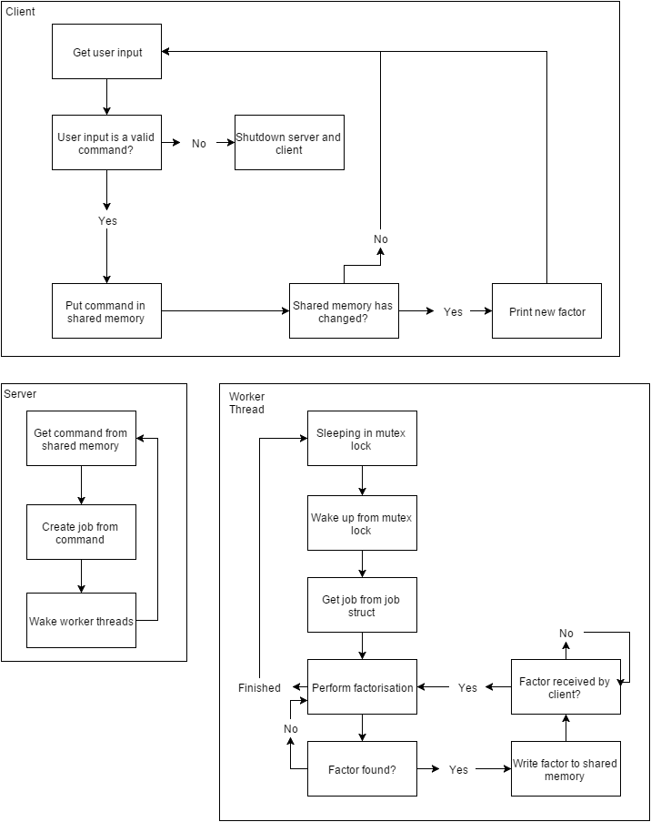

List of all data structures in the software
struct DataStructure // Shared memory
{
uint32_t number; // Used to store and share the number to be factorised
int32_t slot[10]; // Used to return factors
char progress[10]; // Used to return the progress complete for each command
char clientFlag; // Used to tell server there is data to be read from number
char serverFlag[10]; // Used to tell client there is data to be read from relevent slot
clock_t finishTimes[10]; // Used to return finish times and signal factorisation is finished
int shutdownFlag; // Tells server to shutdown
}
struct JobStructure // Server Global Variable
{
int32_t number; // Number to perform factorisation on
int slotNumber; // Slot number to read and write to
int threadNumber; // Thread number out of 0-31
}

Detailed Design (Pseudo Code)

Server
While ( true )
{
If ( client flag = 1 and there is a free slot)
{
Read number from shared memory
Create job with number
Write index of job slot back to number in shared memory
Set client flag to 0
}
}

Client
While ( true )
{
If ( input is ‘q’ )
{
Shutdown server
Shutdown client
}
If ( serverFlag(x) is 1 )
{
Print slot(x)
Set serverFlag(x) to 0
}
}

Requirement Acceptance Tests

Software  Requirement No | Test | Implemented (Full /Partial/ None) | Test Results (Pass/ Fail) | Comments (for partial implementation or failed test results)
1 | The client will query the user for 32 bit integers to be processed and will pass each request to the server to process, and will immediately request the user for more input numbers or ‘q’ to quit | Full | Pass
2 | The client is non-blocking. A up to 10 server responses may be outstanding at any time, if the user makes a request while 10 are outstanding, the client will warn the user that the system is busy | Full | Pass
3 | While not processing a user request or there has been no server response for 500 milliseconds, the client should display a progress update messages for each outstanding request (repeating every 500ms until there is a server response or new user request). The repeated progress message should be displayed in a single row of text that does not scroll up (see example lab 3). The message should be in a format similar to: > Progress: Query 1: X% Query2: Y% Query3: Z% | Full | Pass
4 | If the client is terminated by the user entering ‘q’ or by typing Ctrl-C (cygwin only) it will first cleanly shutdown the server and then print out a nice termination message | Full | Pass
5 | The client will immediately report any responses from the server and in the case of the completion of a response to a query, the time taken for the server to respond to that query. | Full | Pass
6 | The server will not buffer factors but each thread will pass any factors as they are found one by one back to the client. Since the server may be processing multiple requests, each time a factor is found it should be written to the correct slot so the client can identify which request it belongs to. The slot used by the server for responding to its request will be identified to the client at the time the request is accepted by the server through the shared ‘number’ variable | Full | Pass
7 | Since many threads will be trying to write factors to the appropriate slot for the client simultaneously you will need to synchronise the thread’s access to the shared memory slots so that no factors are lost. You will need to write a semaphore class using pthread mutexes and condition variables to used for controlling access to the shared memory so that data is not lost. | Full | Pass
8 | Each factorising thread will report its progress as a percentage in increments not larger than 5% as it proceeds to the server primary thread. The server will use the individual thread progress values to calculate an overall progress % for each request being processed and pass this back to the client in increments not larger than 5%. This will require a second shared array char progress[10] that is 10 elements long but no handshaking protocol or synchronisation since it does not matter if the client misses some values or reads them multiple times | Full | Pass
9 | When the server has finished factorising all the variations of an input number for a query it will return an appropriate message to the client so that it can calculate the correct response time and alert the user that all the factors have been found | Full | Pass
10 | The server will have a dispatch queue driven thread pool architecture where the thread pool size will be configured at startup by means of a command line argument | Full | Pass
11 | The server will take each input number (unsigned long) and will start up either the number of specified threads if given (see Req.17) or as many threads as there are binary digits (i.e. 32 threads). Each thread will be responsible for factorising an integer derived from the input number that is rotated right by a different number of bits. Given an input number input number is K, each thread #X will factorise K rotated right by (K-1) bits. For example say K and it has N significant bits, then thread #0 will factorise the number K rotated right by 0 bits, thread #1 will factorise K rotated right by 1 bit, thread # 2 will factorise K rotated right by 2 bits etc. Rotating an integer K by B bits = ( K >> B) | (K << 32 – B). CLARIFICATION: C= K << (32 – B); Rotated = ( K >> B) | C | Full | Pass
12 | The trial division method should be used for integer factorisation | Full | Pass
13 | The server is must handle up to 10 simultaneous requests without blocking | Full | Pass
14 | The client and server will communicate using shared memory. The client will write data for the server to a shared 32 bit variable called ‘number’. The server will write data for the client to a shared array of 32 bit variables called a ‘slot’ that is 10 elements long. Each element in the array (slot) will correspond to an individual client query so only a maximum of 10 queries can be outstanding at any time. This means that any subsequent queries will be blocked until one of the 10 outstanding queries completes, at which times its slot can be reused by the server for its response to the new query | Full | Pass
15 | Since the client and server use shared memory to communicate a handshaking protocol is required to ensure that the data gets properly transferred. The server and client need to know when data is available to be read and data waiting to be read must not be overwritten by new data until it has been read. For this purpose some shared variables are needed for signalling the state of data: char clientflag and char serverflag[10] (one for each query response/slot) | Full | Pass
16 | The system will have a test mode that will be activated by the user entering 0 as the number to be factored. This will be passed to the server which will launch 3 sets of 10 threads each, each set will simulate one of three user requests. Each thread in each set will return to the client 10 numbers starting with the thread # times 10 and incrementing by 1. For example thread #0 will return numbers 0-9, thread #1 will return numbers 10-19, thread #2 returns numbers 20-29. Progress output will be disabled during the test and it will only run if the server is not processing any outstanding requests instead a warning will be issued to the user | Partial | Pass | It factors numbers 0-29
17 | The source code shall be portable so that it can be compiled and run on Unix and Visual Studio (use can use the built-in win32 semaphore) | Partial | Pass | Can only compile with visual studio command line. E.g. “cl server.c” “cl client.c”

User Instructions

Linux

Compiling

Server
- Open the assignment folder in cygwin.
- Compile using cygwin “gcc server.c –o server”

Client
- Open the assignment folder in cygwin.
- Compile using cygwin “gcc client.c –o client”

Running

Server
The server can accept 1 or 2 command line arguments; number of threads to start and whether to rotate bits or not.

./server [numThreads] [-r]

- Open the assignment folder in cygwin.
- Run the server.exe in Cygwin with desired options e.g: “./server 40 -r” or “./server 40” or “./server -r” or “./server”.

Client
The client has two modes of operation; normal mode and test mode.

Normal Mode:
- Make sure server is running first.
- Open the assignment folder in cygwin.
- Run client.exe in Cygwin “./client”
- Enter numbers to factorise e.g. “987654321”
Test Mode:
- Make sure server is running first.
- Open the assignment folder in cygwin.
- Run client.exe in Cygwin “./client”
- Enter “0” as command.

Windows

Compiling

Server
Run “Visual studio command prompt 2010” and navigate to server file and run “cl server.c“.

Client
Run “Visual studio command prompt 2010” and navigate to client file and run “cl client.c“.

Running (Will have to recompile to run on windows)

Server
Run “Visual studio command prompt 2010” and navigate to server file and run “server.exe“.

Client
Run “Visual studio command prompt 2010” and navigate to client file and run “client.exe

